1. Chatbot Info :

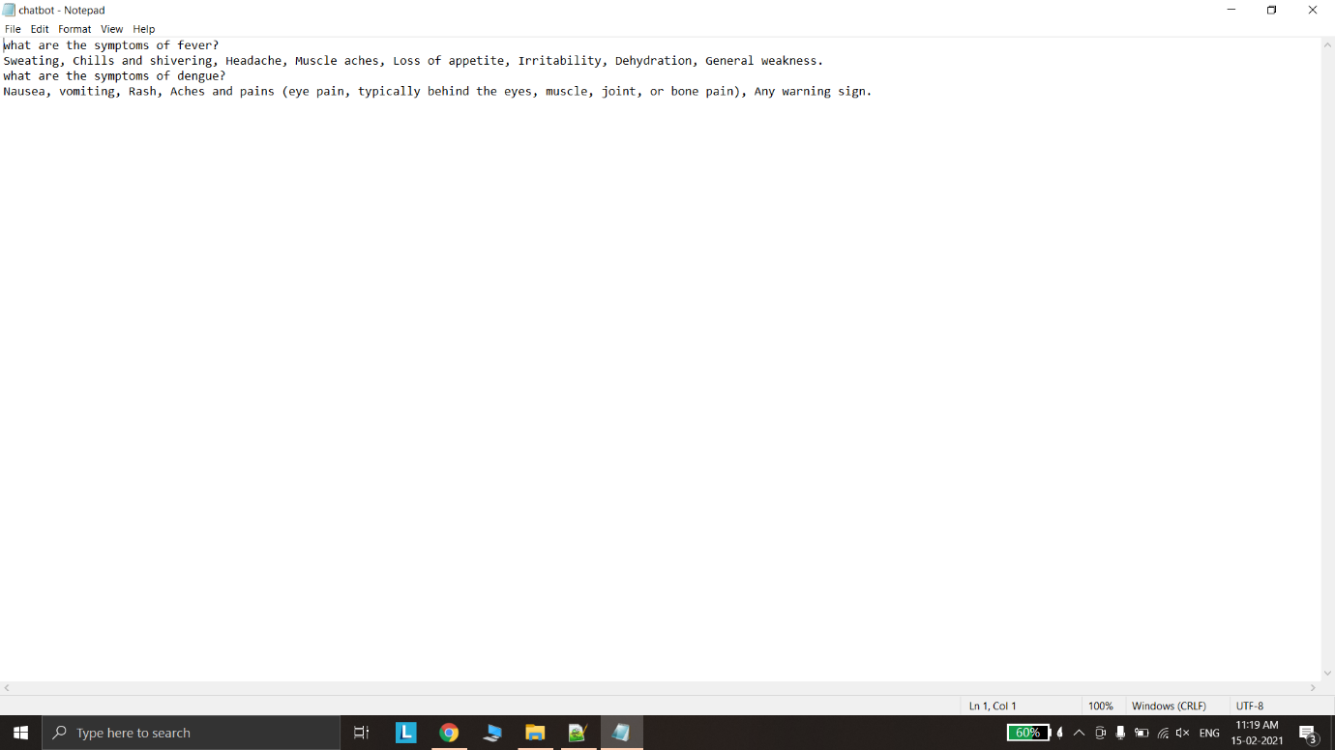

1. Welcome screen :

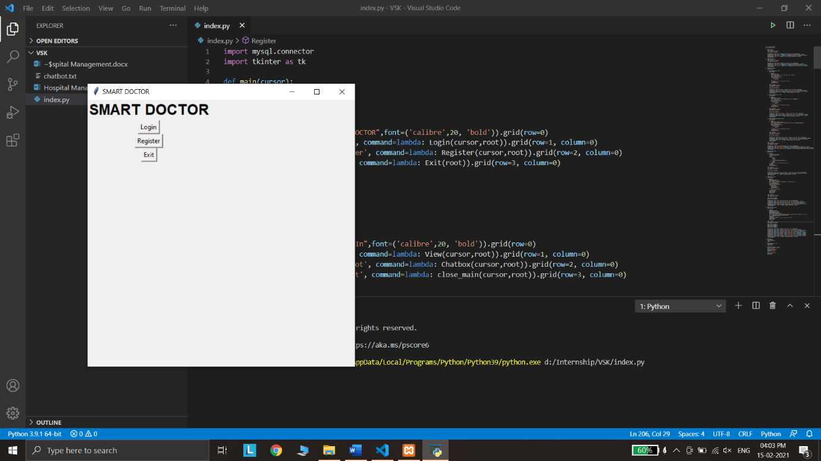

1. Click on register :

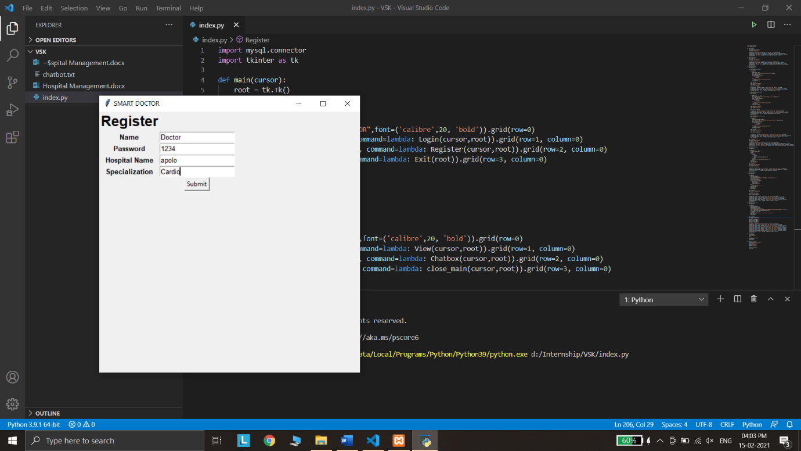

1. Click submit - Database updated :



1. Click on Login :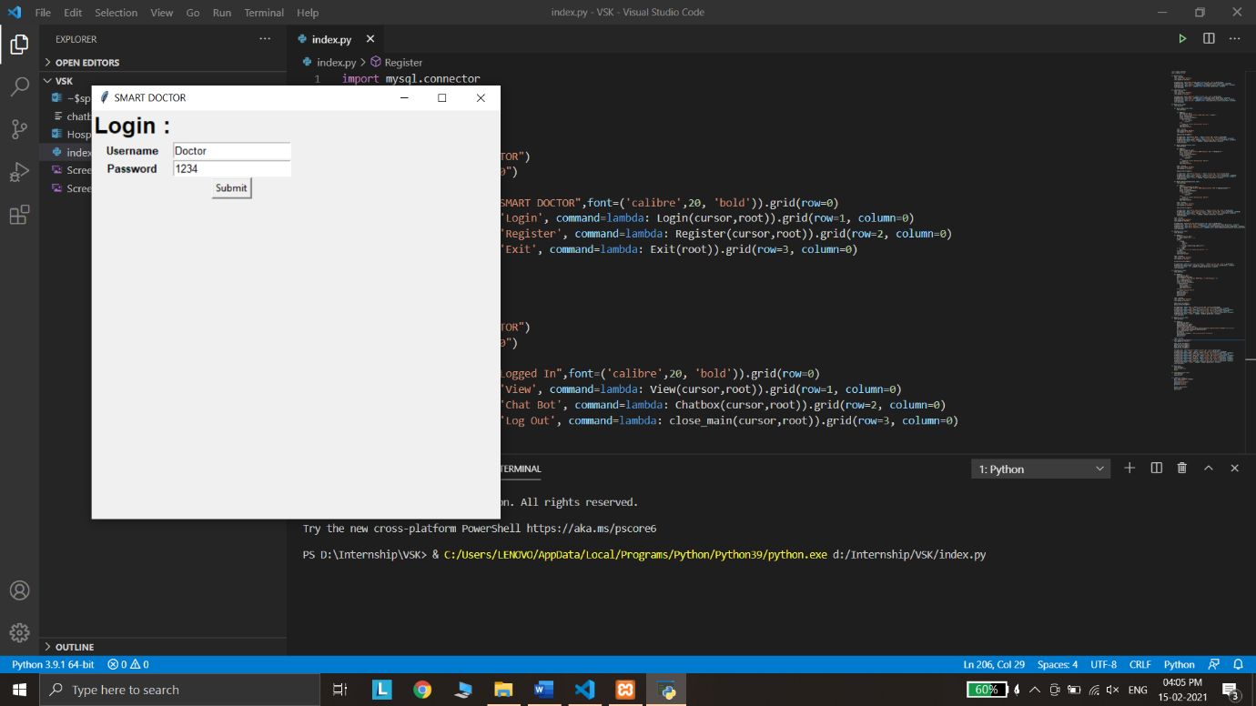
2. Click on Submit – Logged in :

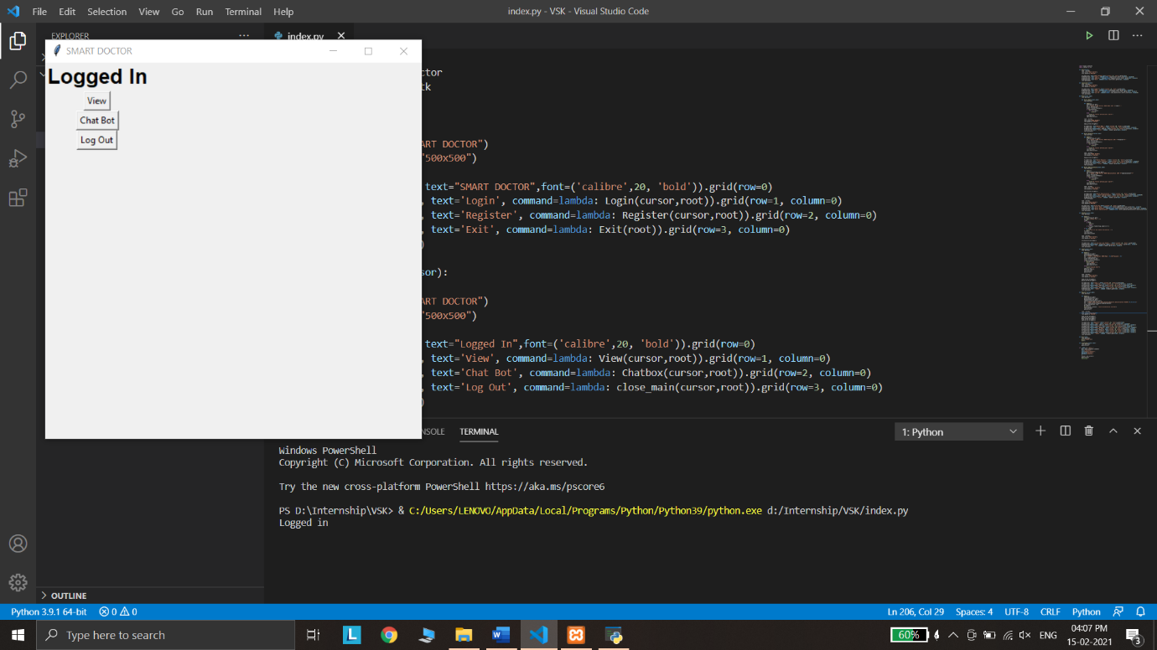

1. Click on view :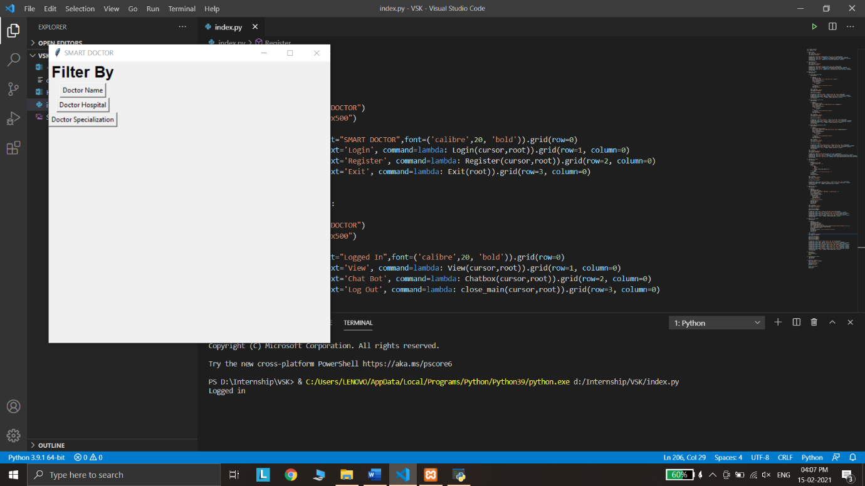
2. Filter by Doctor name :

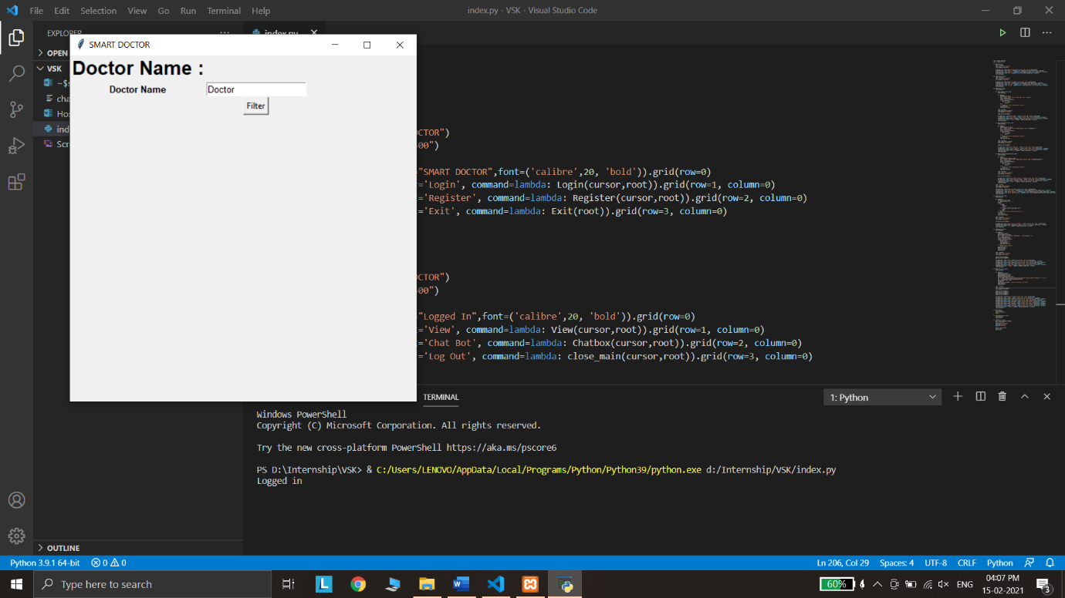

1. Click filter – Results filtered and displayed



1. Filter by Hospital :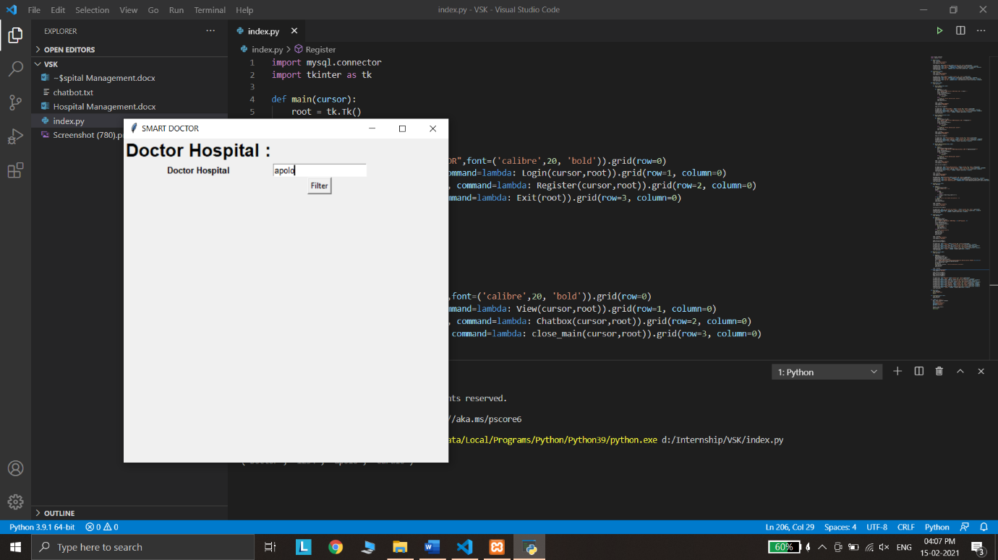

11) Click filter – Results filtered and displayed



12) Filter by Specialization :

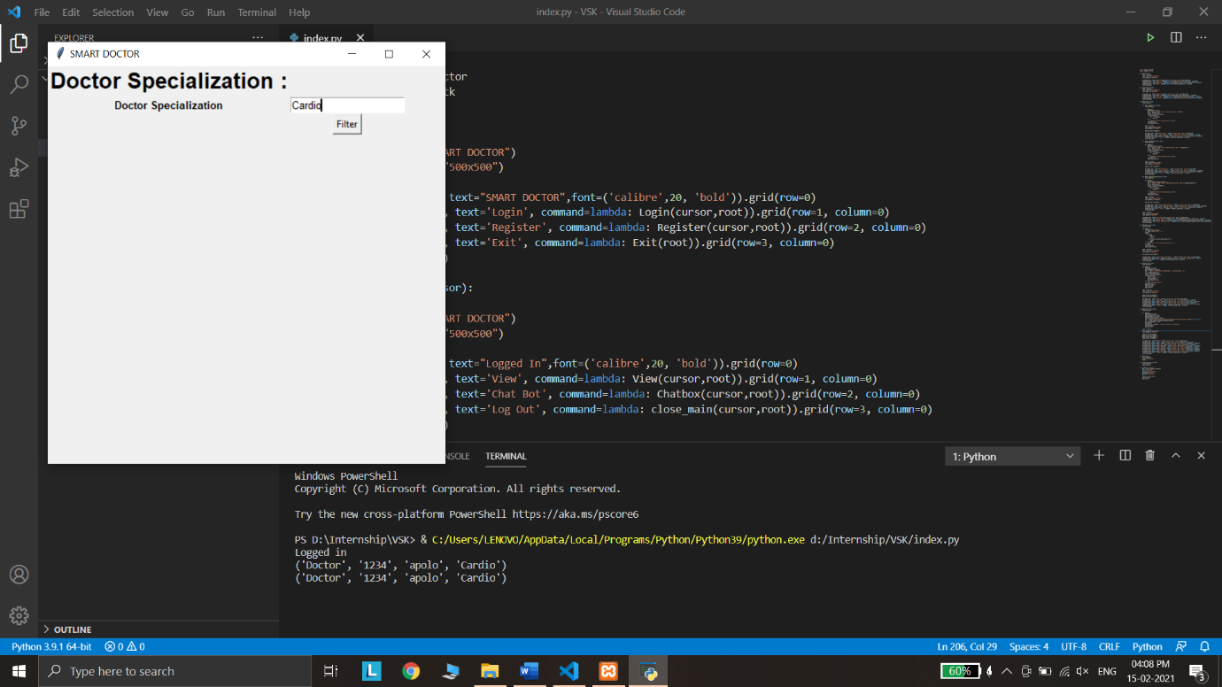

13) Click filter – Results filtered and displayed



14)Click on chatbox :

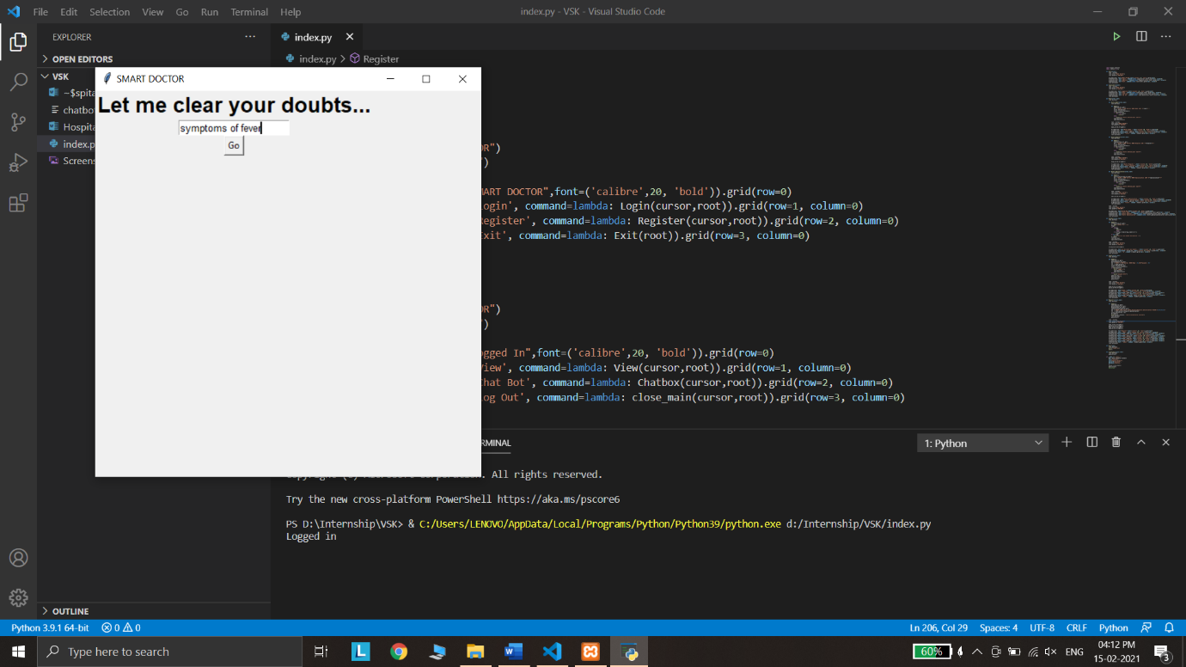

15) click on go and chatbot responded:



16)All results

